Project Design Phase
Solution Architecture

Date | 15 February 2025
Team ID | LTVIP2026TMIDS85825
Project Name | Prosperity Prognosticator – Machine Learning for Startup Success Prediction
Maximum Marks | 4 Marks

Solution Architecture:
Solution architecture is a complex process – with many sub-processes – that bridges the gap between business problems and technology solutions. Its goals are to:
- Find the best tech solution to solve existing business problems.
- Describe the structure, characteristics, behaviour, and other aspects of the software to project stakeholders.
- Define features, development phases, and solution requirements.
- Provide specifications according to which the solution is defined, managed, and delivered.
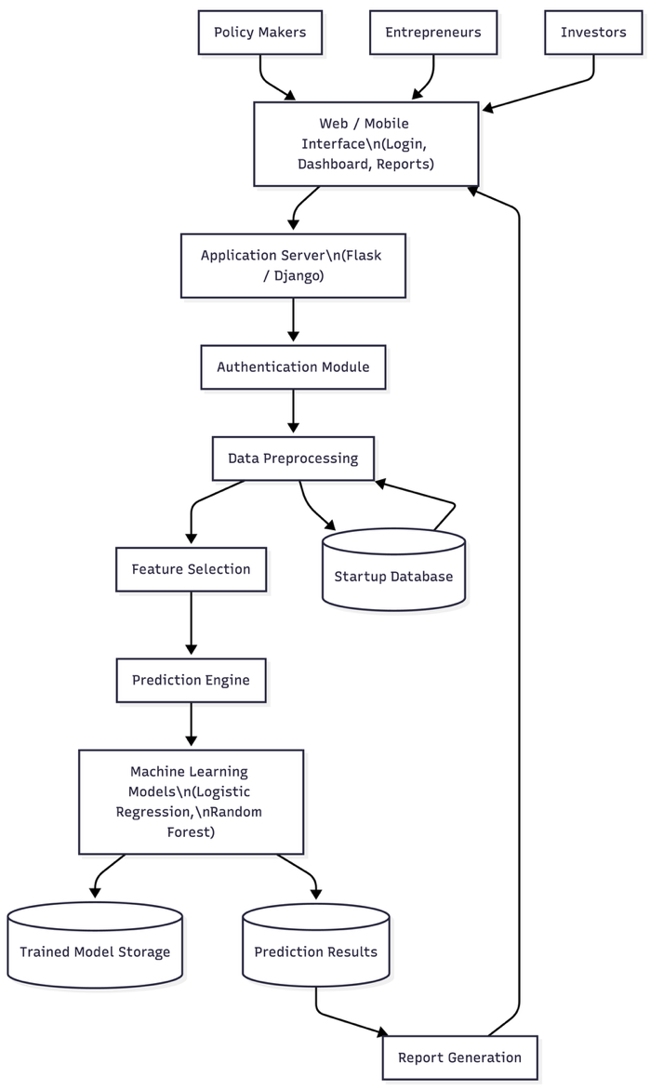

Architecture Flow Explanation
- Users (policy makers, entrepreneurs, investors) access the system through a web or mobile interface.
- The presentation layer allows users to log in, enter startup details, and view prediction results.
- The application layer handles authentication, data preprocessing, feature selection, and communication with ML models.
- The machine learning layer processes the input data using trained models to predict startup success probability.
- The data layer stores startup data, trained models, and prediction results for future analysis.
- The system generates reports and insights to support data-driven decision-making.

Key Architectural Features
- Modular and layered architecture
- Separation of UI, logic, ML, and data
- Supports scalability and maintainability
- Enables easy model upgrades
- Cloud-ready deployment

